A World of Song

Music: An International Language

RTMS Chorus - Fall Concert
October 6, 2021 - 6:30 PM, Gym

Wau Bulan (Malaysian Folk Song) - Tracy Wong
This song describes the beauty of the Malaysian traditional kite (wau) with a rounded bottom shaped like a half moon (bulan) as it flies up high in the sky.
Hand drums: Amy, Anson, Milani, Sebastian, Tara
——-
6th Grade Chorus:
Gallop (from “Solfege Suite”) - Ken Berg
Solfege better known as “do re mi” is a vocal language all it’s own!
Can You Hear Me? - Bob Chilcott
Composer’s note about ASL, American Sign Language: “I have always found it to be an incredibly sensitive and beautiful form of communication-it also served as a reminder to me always to try to be open and aware of other people, and also of our surroundings.”

7th Grade Chorus:
Jabberwocky (from “Join the Dance”) - Carolyn Jennings
Text by Lewis Carroll, famous for his tales of “Alice in Wonderland”
Poem read by: Bhumi & Lilly
Waving Through A Window (from “Dear Evan Hansen”) - Benj Pasek & Justin Paul,
arr. Roger Emerson

8th Grade Chorus:
I Dream a World - André J. Thomas
Text by Langston Hughes, African-American poet and leader of the Harlem Renaissance
Doraji (trad. Korean Folk Song with sung English translation) arr. Ruth Elaine Schram
——-
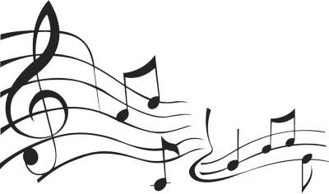
Sisi Ni Moja (We are one) - Jacob Narverud
We celebrate singing together again!
Djembe: Ms. Sally Petty

